Non-Invasive Oxygenation/Ventilation

Conventional Oxygen Delivery Devices

Recommendations for Supplemental Oxygen Therapy

Target SpO2 91-96%: Recent trials of O2 targets found no benefit to higher/lower targets in critical illness

Lower target (Spo2 88-92%): Baseline hypercapnia or at risk for hypercapnic respiratory failure (COPD, OHS, OSA, decreased central respiratory drive, neuromuscular respiratory disease)

Higher Target (SpO2 - 100%): CO Poisoning, cluster headaches, sickle cell crisis, pneumothorax

Mask Type

Nasal Cannula
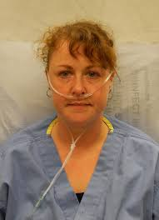
Flow is between 1-6 L
FiO2 is between 24-44%
Notes
FiO2 increases by 0.04 per L, allows patient to eat and speak, consider humidification if >3LPM, it is not aerosolized

Oxymizer
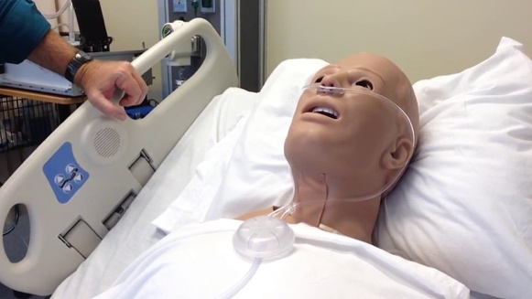
Flow is between 1-15L
FiO2 is between 24-60%.
Notes
20mL reservoir allows for higher FiO2 compared to NC, not aerosolized

Simple Facemask
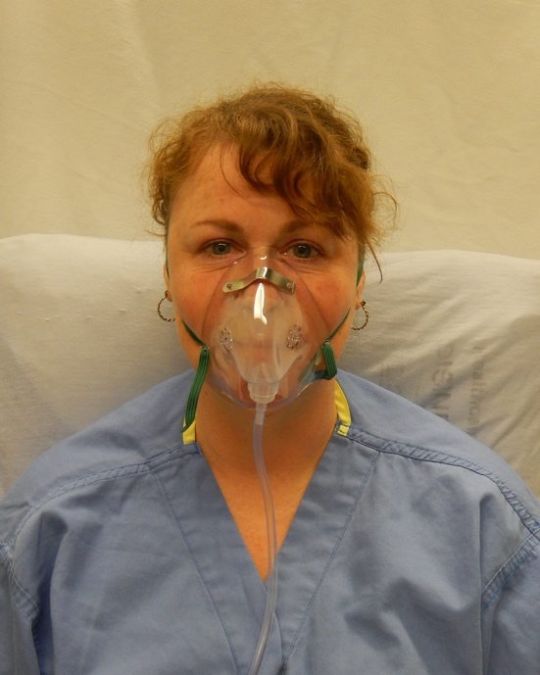
Flow is between 6-10 L
FiO2 is between 40-60%
Notes
Flow rates <6LPM leads to rebreathing of CO2, not aerosolized

Face Tent (Shovel mask)
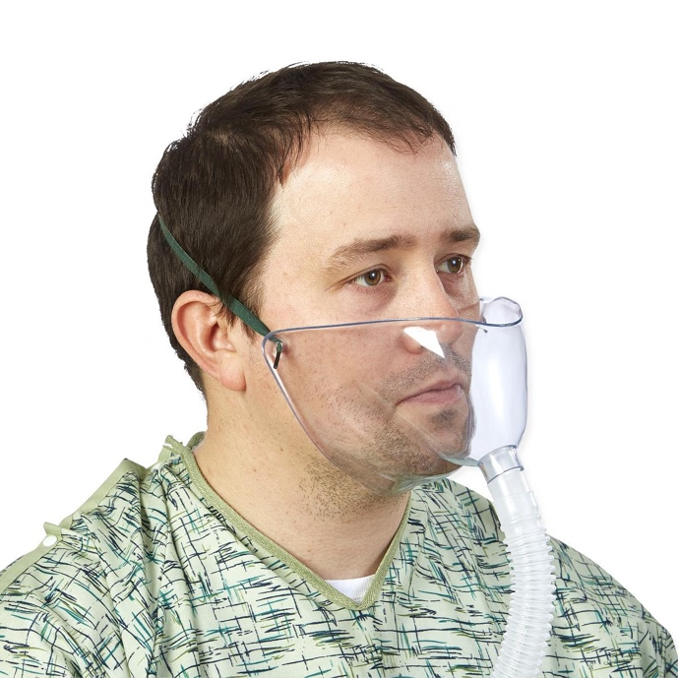
Flow is 10-15 L
Fio2 is between 28-100%
Notes:
less claustrophobic, FiO2 variable (lots of leakage) due to lack of nose seal. You should use this if stable o2 needs, not good for high FiO2 delivery. Offers humidification without a mask, it is aerosolized if humidified

Non-rebreather
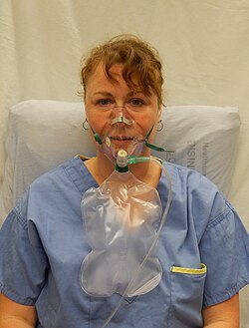
10-15 L
FiO2 is 60-90%
Notes
Consider first for acute hypoxemia as it is easily accessible, increase Fio2 with tachypnea and increased ventilation due to entrainment. titrate flow rate to avoid reservoir bag collapse (<1/3) on inspiration, not aerosolized

Venturi
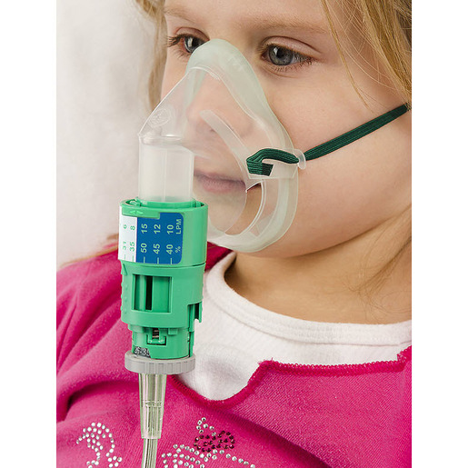
Variable flow rate
FiO2 24-60%
Notes
Color coded adapters determine flow and FiO2 independent of ventilatory demand. Useful for set Spo2 goals for example copd, not for acute respiratory distress, it is aerosolized, if greater than 15 liters per minute or humidified.

Racial disparities in pulse oximiter measurement
Decreased accuracy in black patients lead to increase in occult hypoxemia, can be addressed by having a low threshold for VBG and clnical signs like increased RR and effort, cyanosis, dyspnea, chest discomfort, and mental status changes.

High Flow Nasal Cannula & Noninvasive Positive Pressure Ventilation (NIPPV)

High Flow Nasal Cannula
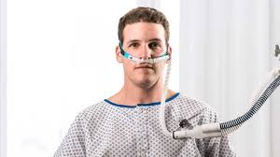
Parameters
Flow 10-60 LPM (up to 80 LPM at some institutions)
Fio2% between 21-100
PEEP generated with a closed mouth is about 1 cm of water pressure for 10L flow

Physiologic Effects
Increases oxygen delivery of some o2, some PEEP
Increases ventilation (decreased dead space during expiration)
Humidification increases mucocilliary clearance of secretions

Clinical Scenarios where it is useful

Acute hypoxemic respiratory failure
Mixed evidence in Non-hypercapnic respiratory failure. May decrease intubation, but no change in mortality or length of stay vs standard o2 therapy. Consider HF 1st if ILD, ARDS physiology, and may be non inferior to BIPAP in pneumonia. Can be used as rescue in asthma or in patients that can’t tolerate biPAP to help with dead space washout and intubation evaluation

NIPPV (CPAP + BIPAP)

Parameters
CPAP = constant level of positive pressure; targets oxygenation
BIPAP: provides positive inspiratory pressure (IPAP) above PEEP with each patient triggered breath; targets ventilation and oxygenation

Physiologic Effects
Oxygenation: decreases atelectasis, decreases upper airway obstruction, decreases work of breathing and oxygen consumption
Ventilation: increases tidal volume and minute ventilation via ipap.
Other: decreases venous return (decreasing LV and RV preload), decreases LV afterload

Clinical Scenarios where it is useful

Acute hypoxemic respiratory failure
NIPPV may decrease mortality and decrease intubation. Can also consider if also signficiant hypercapnia such as ohs, neuromuscular failure such as ALS and MG.

Caveats
If PaO2/Fio2 ratio is less than 150, this increases death vs up front intubation. If TV >9-9.5 cc/kg/IDW: this increases death, increases intubation.

Acute COPD exacerbation with respiratory acidosis
Strong indication for BIPAP to off load respiratory muscles, counteract dynamic hyperinflation, increase ventilation and decrease mortality, decrease intubation, and decrease length of stay. Asthma can be treated similarly but there is less evidence to support

Acute cardiogenic pulmonary edema
NIPPV decreases intubation, decreases in hospital mortality by decreasing work of breathing, increases functional residual capacity, decreases lv/rv preload, decreases LV afterload

Post extubation
Extubation to NIPPV or HFNC to decrease reintubation and post extubatation respiratory failure in increased risk patients: COPD, obesity

Contraindications to NIPPV

Risk of delay: can increase latency between intubation, acute life threatening non respiratory organ failure
Risk of aspiration (d/t gastric insufflation): cannot clear secretions, AMS if patient cannot remove mask (exception: AMS due to hypercapnia)
Risk of injury: PTX (can induce tension physiology), recent esophageal anastomosis or tear, cannot tolerate decreased preload from decreased venous return, recent facial trauma and surgery

Monitoring for and preventing failure

Risk of failure varies based on the cause (15-20% COPD exacerbations, 40-60% AHRF) and increases with severity of respiratory failrue
ROX index is a tool for prediction of HFNC failure and monitoring for need for intubation in patients with pneumonia
HACOR score is a tool for prediction of NIPPV failure and need for intubation
Sedation: IV precedex, Haldol, and Zyprexa can be considered to help patients tolerate NIPPV without suppressing respiratory drive.

BiPAP/HFNC on the floor: huddle with nursing and RT. Trial BIPAP or HFNC for 2-3 hours and assess response; consider ABG/VBG to assess oxygenation/ventilation. If no improvement, discuss escalation of care to ICU. Remember that bipap/hfnc must not delay an indicated intubation.

