COPD
Definition: Persistent respiratory symptoms such as dyspnea, cough, sputum production, recurrent wheezing, or exacerbations due to abnormalities of airways such as bronchitis, bronchiolitis, and or alveoli (emphysema) that lead to persistent airflow obstruction

Diagnosis and Staging
Diagnosis of COPD requires respiratory symptoms + fixed obstruction with FEV1/FVC ratio less than 0.7 or less than normal limit on spirometry post bronchodilator.

GOLD Grade (1-4) is defined by severity of airflow limitation (FEV1% of predicted) helps establish prognosis and guide non medical therapy

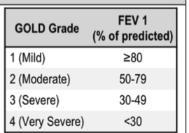

GOLD Group (ABE) defined by exacerbations and sx guide the therapy using mMRC - modified medical research council dyspnea scale and CAT score - copd assessment test

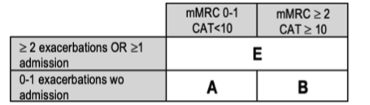

Other testing include lung volumes, DLCO (<60% airway symptoms, exercise, decrease health), exercise test (6MWT - 6 minute walk test) a1 antitrypsin

Differential (Other things you have to think about besides COPD)

Pre-COPD = this is when the patient has respiratory symptoms with structural lung lesions (emphysema) and/or phyisological abnormalities without airflow obstruciton. In this case the FEV/FVC ratio will be preserved. This spirometry will show that there are symptoms with normal ratio but impaired fev1 (<80) after bronchodilation.

Chronic bronchitis: this is a overlapping conidtion, in which you will have chronic cough + sputum for more than 3 months a year for 2+ years.

Asthma: For this one you will have obstructive spirometry findings but reversible after bronchodilation.

Bronchiectasis: Large volume of purulent sputum alive and well bacterial infection and bronchial dilation on CXR/HRCT

Obliterative bronchiolitis: consider after lung/BM transplant, HRCT: hypodense areas on exp

Diffuse pan bronchiolitis: Asian patients, chornic sinusitis, CXR/HRCT: diffuse small centrilobular nodlar opacities and hyperinflation

Management of Stable COPD

Pharmacologic Interventions: will decrease symptoms, decrease the risk and severity of excacerbations, increase the health status and survival

For Gold A
Starting therapy: Bronchodilator (LABA or LAMA)
Rescue Therapy: Short acting bronchodilator
Escalation:
Dyspnea: LAMA + LABA
Exacerbation: LAMA + LABA
Note: Long acting inhalers are better than short acting unless this is occupational dypsnea
Tiotropium may slow the decline in FEV1 in early COPD

For Gold B
Starting therapy: LABA + LAMA
Rescue therapy: Short acting bronchodilator
Escalate to :
Dyspnea: Switch inhaler device or molecules, Nebulizers may be helpful in severe COPD
Exacerbation: Eos>100: LAMA + LABA + ICS, consider adding biologics such as dupilumab; FEV1 <50% + bronchitis, eos <100: Roflumilast; former smokers : Azithromycin
Notes: LABA + LAMA is better than monotherapy

Gold E
Starting therapy: LABA + LAMA. If eosinophils are greater than 300 or asthma: LABA + LAMA + ICS
Rescue Therapy: Short acting bronchodilator
Escalate:
Same
Notes: Include Inhaled corticosteroids if features of asthma/ LAMA + LABA + ICS is better than just LAMA + LABA to decrease exacerbations, may increase the risk of pneumonia. Can consider d/c if w/ICS there is persistent exacerbations or pneumonia.

Common COPD Inhalers

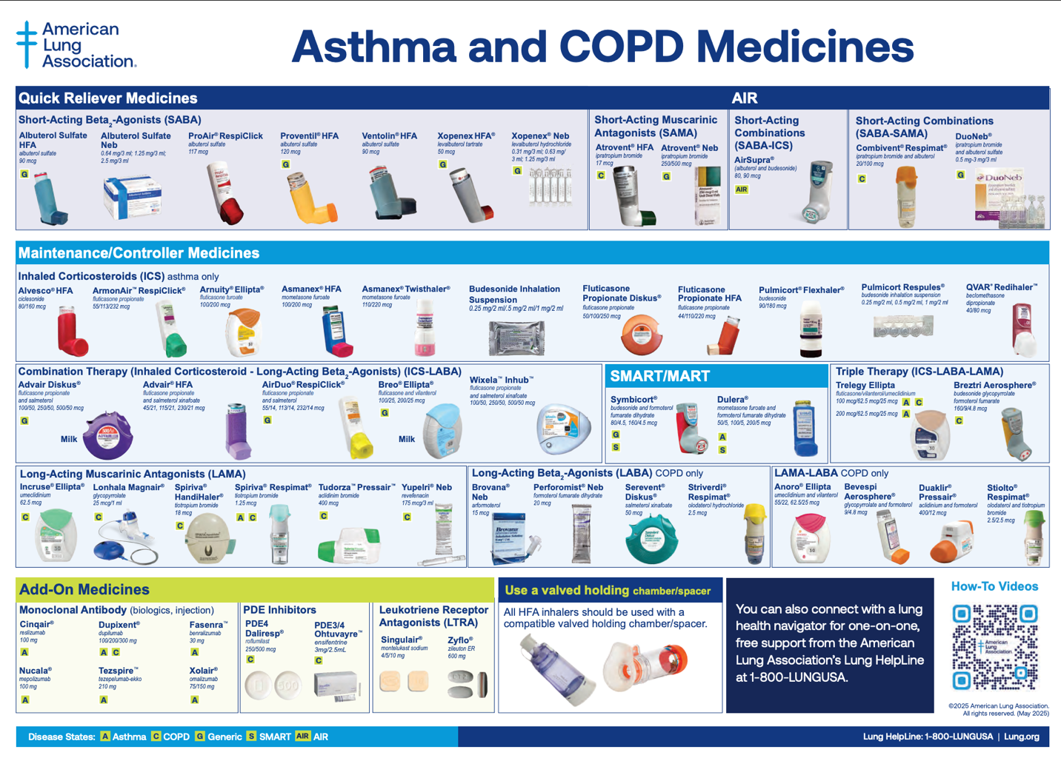

Non RX interventions:

Smoking cessation: decreases mortality
Vaccination: Flu, COVID, PCV20, Tdap, Zoster, RSV
Lung CA screening: annual low dose CT (age 50-80 & >= 20 pack years and has smoked in the last 15 years)
Pulmonary Rehab (GOLD B/E): Increases quality of life, increases exercise capacity, possibly decreasing mortality
Home O2: If PaO2 <=55 or Spo2 <=88% (if PaO2 <=59, or SpO2<=89% in pulmonary HTN, HCT>55%, or CHF) for goal SpO2>90%, reassess in 60-90d
Nocturnal NIPPV: if daytime PCO2>53 and noctural Spo2 <=88% (despite 2L o2) or recent exacerbation and persistent CO2 >53 (decreases the risk of readmission and mortality)
Interventional therapies: bronchoscopic lung reduction (emphysema + hyperinflation), bullectomy
Lung transplant: progressive diagnosis despite max prescription; non surgical candidate if BODE index 5+, frequent exacerbations, low FEV (20-25%) or rapidly increasing BODE (body mass, obstruction, dypsnea, exercise - calculator you can use)

COPD Exacerbation
From the history:
if they have increased dypsnea, increased or change in sputum and/or cough <14 days; can ask if they had any prior exacerbations, any steroids, intubations, or antibiotics use

Differential: URI/PNA, CHF, VTE

Workup: CXR , ABG/VBG, ECG, trop, NT-proBNP, Sputum culture, RVP (right ventricular pressure), CRP, PE (in 25% severe exacerbation without clear trigger)

Management:
SPO2 88-92%: hyperoxia, decreases ventilation via Haldane Effect and hypoxic vasoconstriction which increases the v/q mismatch, and increases mortality

Bronchodilators: albuterol, ipratropium, duonebs (combo) initially -> space to standing duonebs q4 with albuterol prn every 2 hours, space further as able

Steroids: prednisone 40mg x 5 days. PO vs IV. 5d is non inferior to 14 days, some may need higher dose and longer course if severe but this increases the pneumonia risk. Iv severe IV methylprednisone 60-125 mg q6-q12 x 72 hours, budesonide nebulizer treatment

NIPPV: if respiratory acidosis (ph<7.35 and PaCO2>45), if there is severe dyspnea, if increased work of breathing, persistent hypoxemia, if increased mortality, if there intubation, if there is increased length of stay

intubation: if there is failure of noninvasive ventilation, status post arrest, if aspiration or vomiting, if patient is on a high dependency unit.

Antibiotics: Controversial, decreases the mortality but challenging to identify who will benefit
- it is indicated if has all 3 cardinal symptoms of COPD exacerbation (worsening dyspnea, increased frequency and severity of cough, increased volume and or purulence of sputum), or 2/3 with increased sputum purulence, or require NIPPV/mechanical ventilation. CRP can be useful to determine if indicated, procalcitonin may be useful but can increase mortality when used in ICU
-choosing is based on psuedomonas aeruginosa risk, prior sputum culture, resistant. if no psa risk factors: CTX, FQ, amox/clav, azithro, doxy. if psa risk factors: fluroquinolones, cefepime, pip/tazo. duration: 5-7 days in patient, 3-5 outpatient. if concurrent cap: treat by cap guidelines

antivirals: oseltamivir if flu a, even if >= 48-72 hours

VTE ppx

Inhale therapies for asthma and copd
- short acting b agonist (SABA) - albuterol, levalbuterol (side effects include increased HR; levabulterol is more selective so less HR effect but increased money)
-short acting muscarinic antagonist (SAMA) - ipratropium (atrovent) (side effects include urinary retention, dry mouth)
-long acting b agonist (LABA) - salmeterol, formoterol (nebulized budesonide: in asthma, do not use without inhaled corticosteroids)
-long acting muscarinic antagonist (LAMA) - tiotropium (spiriva) umeclidinium (incruse elipta)
-inhaled corticosteroid (ICS) + LABA: Fluticasone-salmeterol (Advair), budesonide-formoterol (symbicort), mometasone-formoterol (Dulera), fluticasone-vilanterol (Breo elipta)
-LABA + LAMA: umeclidinium-vilanterol (Anoro Elipita)
-LAMA + LABA + ICS: Fluticasone-umeclidinium-vilanterol (Trelegy Elipta)

